**Get ROOT and WASADMIN access**

Please raise 2 tickets on service now. One for wasadmin and other for root access

Service now link - <https://atyourserviceportal.service-now.com/>

**Path** :

•  [Technology Service Catalog](https://atyourserviceportal.service-now.com/catalog_home.do?sysparm_view=catalog_technical_catalog&v=1&sysparm_catalog=742ce428d7211100f2d224837e61036d&sysparm_catalog_view=catalog_technical_catalog&sysparm_view=catalog_technical_catalog)

•  [FIS Cloud Services (Former Global Development Operations FISDEV)](https://atyourserviceportal.service-now.com/com.glideapp.servicecatalog_category_view.do?v=1&sysparm_parent=1c85e7011b5190d4cd94740e1d4bcb3f&sysparm_no_checkout=false&sysparm_ck=8597aed81bfa9010fc8a2f0a2d4bcbc3aba4ba960bc09c1ad5ec603c4d5b23bb94729b03&sysparm_view=catalog_technical_catalog&sysparm_catalog=742ce428d7211100f2d224837e61036d&sysparm_catalog_view=catalog_technical_catalog)

•  [FISDEV Cloud Operations](https://atyourserviceportal.service-now.com/com.glideapp.servicecatalog_category_view.do?v=1&sysparm_parent=ce3c65a34f0bf640e6da69118110c7de&sysparm_no_checkout=false&sysparm_ck=8597aed81bfa9010fc8a2f0a2d4bcbc3aba4ba960bc09c1ad5ec603c4d5b23bb94729b03&sysparm_view=catalog_technical_catalog&sysparm_catalog=742ce428d7211100f2d224837e61036d&sysparm_catalog_view=catalog_technical_catalog)

•  [Unix/Linux User Access](https://atyourserviceportal.service-now.com/com.glideapp.servicecatalog_category_view.do?v=1&sysparm_parent=7f90a3fd4fd06b00b766ea7d0210c77f&sysparm_no_checkout=false&sysparm_ck=8597aed81bfa9010fc8a2f0a2d4bcbc3aba4ba960bc09c1ad5ec603c4d5b23bb94729b03&sysparm_view=catalog_technical_catalog&sysparm_catalog=742ce428d7211100f2d224837e61036d&sysparm_catalog_view=catalog_technical_catalog)

•  Server Access Request

**Steps**:

1. Enter machine name

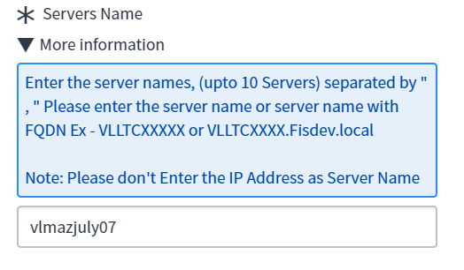

1. Select Level of Access. Refer to point ‘a’ if you are raising wasadmin request and point ‘b’ if you want to raise root access request. 2 individual tickets should be created for both accesses
   1. **For Wasadmin access**

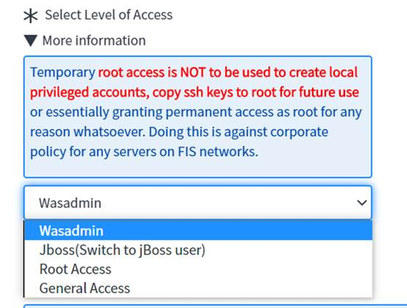

* 1. **For Root access**

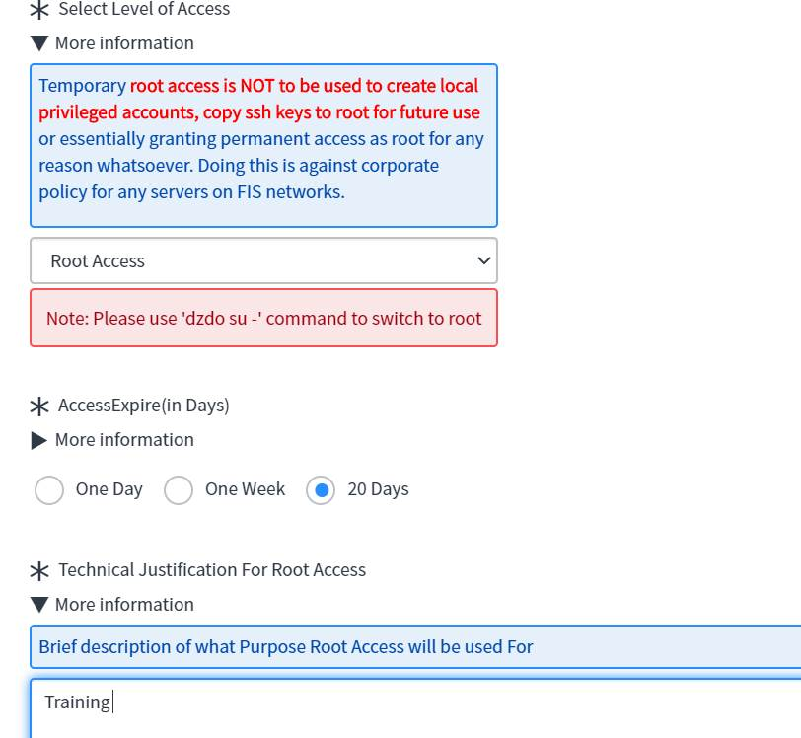

1. Select user

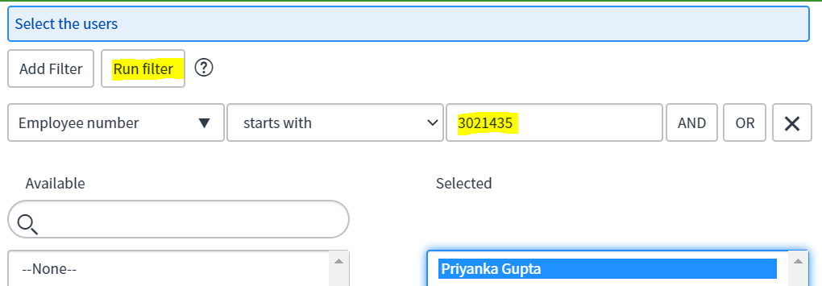

1. Submit order

